|  |
| --- |
| **Website Development** |
| Individual report |
|  |
|  |
|  |
| **Daniel McHugh - 13005235** |
| **4/25/2016** |
|  |

Contents

Website Design Principles 3

Legality issues 3

Professional Issues 7

Usability Issues 9

Design and Implementation 11

Promoting the Website 13

Planning, Research and Contribution 15

Appendix 24

Technical Documentation 24

Reference list 69

# Website Design Principles

## Legality issues

Below I will be talking about the legality issues when creating a site this will be an overview of what each law is and how it affects designers when they are creating their sites.

**Copyright law**When talking about the copyright law the first thing you need to understand what is the copyright law and how does it affect website operators as when you understand how the law works you then can start to understand how they are shaped in order to protect people and their works. The copyright law was established to protect the originality of someone’s work this is the main use of this law but another principle is to make sure it is not duplicated or misused by other people so if they started to make a profit off another person’s work you could then apply the copyright law to that person not only does this protect the original owner it stops people from creating and selling counterfeits products.

In order for work to be classed as copyright we follow three simply rules the first is that the work has to be original it cannot be a copy of another work. The second one is it must be creative as most original works are and the last one is that it must have a definite medium of expression. Works that are included in the copyright law are…

1. Literary works including computer programs.
2. Music works.
3. Dramatic works.
4. Pantomimes and choreographic works.
5. Pictorial, graphic, and sculptural works.
6. Motion pictures and other audiovisual works.
7. Sound recordings.
8. Architectural works.

So if we take the copyright law and apply it to a website we can start to see what would be protected under that law for example images on the site if they are logos or character designs then these would be protected as they would be seen as artistic works. Also text would be protected under this law for example a catchphrase would be copyright so you wouldn’t be able to use this text also while we are talking about text we can say that code would be protected as well as it would be seen as literary works. Now you can start to understand that learning these laws and how they could affect a website operator can save businesses a lot of time and money as breaking these laws can result in huge losses.

**Data Protection**

When talking about the data protection law the first thing you need to understand what is the data protection law and how does it affect website operators as when you understand how the law works you then can start to understand how they are used to protected peoples information another principle to talk about is that anyone has the right to ask any business what information they have about them. This law was introduced in the 1980s to protect individuals against the growing use of their data in computer systems so this could be anything from storing information about someone or a group of people to using the collected information to target certain people in that group when businesses started to use and collect more data the government then updated the law which strengthened it this was in 1998 as the growing use of data continued more specific laws were put in place to tackle what could happen to your online data when a business stored it this was introduced in 2003.

The most important part of the DPA is that it covers the processing of personal data this data not only includes your name, address, age and DOB but any data that could be reasonably be put together with other information to divulge personal information about yourself for example your e-mail would be include in this as by using a person e-mail you can gather other information about that person helping your collect personal information about them. The term ‘processing’ relates to pretty much any operation on your data which involves a computer so if your data was selected as a test group or it could be as simply someone reading them off a screen as you can see its very important that businesses know how to handle our data as it could lead to it being misused.

There are rules that need to be followed when handling data these are them…

1. Used fairly and lawfully.
2. Used for limited, specifically stated purposes.
3. Used in a way that is adequate, relevant and not excessive.
4. Accurate.
5. Kept for no longer than is absolutely necessary.
6. Handled according to people’s data protection rights.
7. Kept safe and secure.
8. Not transferred outside the European Economic Area without adequate protection.

As talking about above anyone has the right to ask what information any business has on them but on some grounds a business can withhold information from you if it follows one these rules

1. The prevention, detection or investigation of a crime
2. National security or the armed forces
3. The assessment or collection of tax
4. Judicial or ministerial appointments

**Disability and the Equality Act 2010**

When talking about the disability and the equality act the first thing you need to understand what is the disability and the equality act and how does it affect website operators as when you understand how the act works you then can start to understand how you can better your website to help people with these needs. Under the equality act you are disabled if you have a physical or mental impairment that has a substantial and long term negative effect on your ability to do normal daily activities before we go into what this means to a website some terms need to be explained the first one is ‘substantial’ this is more than minor or trivial for example it takes much longer to do a normal task an example of this would be getting dressed another term is ‘long-term’ this means more than 12 months these are the rules when it comes to disability. Now if we apply this to a website is can become hard to follow these rules as how can you design a website around the idea of a physical disability and there are thousands which all have different traits the best way to think about this is to find common ground then adapt from this.

When we talk about equality it covers a huge amount of characteristics that must be enforced as it is the law it also blends with another law which is discrimination as both of them are very similar they are normally placed together. These are the equality act rules that protect you from discrimination also as both laws are tied together the different types of discrimination will be listed as well…

1. Employment.
2. Education.
3. Access to goods, services and facilities.
4. Buying and renting land or property.

As you can see when you look at both their go hand in hand as to refuse service to someone would be seen as discrimination and equality as you aren’t treating them fair.

1. Age.
2. Being or becoming a transsexual person.
3. Being married or in a civil partnership.
4. Being pregnant or having a child.
5. Disability.
6. Race including colour, nationality, ethnic or national origin.
7. Religion, belief or lack of religion/belief.
8. Sex.
9. Sexual orientation.

**Privacy Policy**

When talking about the privacy policy act the first thing you need to understand what is the privacy policy act and how does it affect website operators as when you understand how the act works you then can start to understand how you can better your website to help people with these needs. When talking about the privacy policy there are certain rules that you need to understand as this act has a very open ended title it can be hard to understand what “privacy” is on the internet but there are a few guidelines that will help you get a better understanding first of all the privacy policy does allow websites to gather information about you this could be from what browser you are using to what you did on the site. As you can see none of this information is personal this is one of the features of the act websites are allowed to gather data but they can’t use that data to identify anyone so as the name says it protects your privacy while using that person site.

The way websites collect this data can differ from site to site but most of them are the same the first one could be a feedback page or a questions page where the user would enter in data and send it to the business this type of data gathering is on all if not most websites and allows users to have a voice so they can say what they think. The next is cookies these are on every website as they allow the site to gather information without the user having to do anything these are less targeted at the business and more forced at the site and how users are using it these are very helpful if you want to improve your site.

Here are a few guidelines to help you understand the privacy policy

1. Questions, queries or feedback you leave, including your email address if you send an email to GOV.UK.
2. Your IP address and details of which version of web browser you used.
3. Information on how you use the site, using cookies and page tagging techniques to help us improve the website.
4. Details to allow you to access government services and transactions, eg an email address (you’ll always be told when this information is being collected, and it will only be used for the purpose you provide it for).

## Professional Issues

When creating any type of system that involves human interaction there will be several issues that will continue to come up some of these are legality, sociability, ethics and professionalism trying to create any system that balances these four issues can be difficult as they contain a lot of rules and information about what a system should have. In this part of the report professional issues will be covered this will link back to the legality issues as by using the acts and laws set we can design a system that is professional. Now when we think of the word professional we think of something that is an expert in their field for example a web design would be a professional in their field also a teacher would be a professional in their field so what professional issues could we have when creating a website one of these issues could be the language we use on the site as the language we use would have a massive impact on who we can commutate to.

As some sites don’t accommodate to other peoples language this creates a barrier that can’t be pasted and causes people that can’t understand that language to leave the site not only is this very unprofessional but it also goes against the equality act as you are not allowing certain people to use your site just because they can’t understand your language. This has been one of the main issues that will plague any designer as to make a site that every language can understand is not easy but as the same time it is not impossible one of the methods that design will use is to incorporate images as they are easier to understand than text. This can easily explain what a block of text is telling to user for example if you were creating a website for a fashion company and you wanted to tell the user that a discount was going to happen on a certain day then you would use an image that would not only tell the user what was on sale but how much the product is discounted so as you can see by the use of images we can tell the user what message we need without using any text.

This kind of method can be used for many different purposes another could be to tell the user how to do a certain operation on the site an example of this could be a link to one of the many social media sites so instead of having text saying “if you would like to share our content please click on one of the following links” you could instead have a small images with the logo of each social media site this tells the user that when they click on this image it will take them to that website. Another method a designer could use is when the user’s loads up their site a select your country screen will appear before they enter the main site this will allow the user to select their own language this will then take them to a site that is in their own language so they can understand the website. Alongside this most browsers can translate text to the users own language so the need for another screen to select your own country does seem pointless but not all browsers have good translates of text so if you wanted to make sure you are getting the right message across to the user it would be more safe to have the other method in place also it looks more professional if you are taking foreign user into account when designing your site.

Another professional issue that is related to language is the use of words and the spelling of these words as every county has their own language and different ways of using words for example as to spelling in the English language the word colour is spelt with a “U” in it but in other countries like the USA they spell it without the “U” so it would be color this might be a small issues but these some issues can add up and cause some people to totally miss the point of your message and as a designer you don’t want the users to feel unsure about what they are reading. Also when we use words some have more than one meaning or will mean something different when joins with other words an example of this is could be “type” type can mean two different meanings when you put it in a sentence so you could say that “He can type so fast” which means that he can type on a computer really fast compared to “She isn’t really my type of person” which means that you dislike or don’t think that you two will get along well together as you can see these two have very different means so as a designer it is very important that you know the difference as some people won’t understand the message you are telling them.

Another professional issue that designers will come into contact with is the usability of images and other external sources this is a very important issue in any website design as if you are using a lot of external sources you are more at risk of using other people’s works which would go against the copyright law as the law is in place so people that have created original work have the right to do what every they want with their works. For example if you are a designer that wanted to have someone else’s logo or image on your website you would first need to contact them to see if they would allow you to use one of their works after this you might need to pay for the use of this image when you have obtained the rights to that image you can use it as much as you want.

But if you didn’t contact the owner of the image and used it anyway you could be asked to take down the site forcing you to remove the image this would be the least worrying issue that could happen some of the more serious cases have been a heavy fine which not only will affect you but it will also hurt the clients as well as they would have to give consent before you could publish the site. This would damage the businesses reputation which is very important as most businesses won’t want to work with businesses that do shady actions and it would damage your reputation as well this could mean that other businesses won’t want to hire you as you are not a creditably designer.

Another professional issue that closely follows language is text as text will be one of the most common features about your site you will have to make sure that all text follows the home pages example so if you have text that is size 12 and font Calibri you have to make sure all text that is in the same location is the same this is very important and make the whole site look more organized but it doesn’t stop at that location has to be the same as well for example if you have text on the left site of the site and an image on the right the next page should follow this example as so on this makes the site look a lot more nice and organized which will help the users.

## Usability Issues

When we talk about usability issues we are talking about issues that the user could have when interacting with the site this could be down to bad design work or the designer not thinking about people with special needs these two factors can make a website unusable so it is very important that designers research the main issues that are affecting users while using a website this information can be very valuable when creating your own site as you will be able to fix certain issues that other sites haven’t making your site better which will make your client happy. One of the features that can make a site unusable is colour if you don’t have a good colour scheme then you are already making your site unusable as no user will want to use a site that looks bad not only does this affect the background it includes titles, text and heading if any of these don’t match the colour scheme you are going for then you will have a site that looks very unprofessional this might seem like a small feature in a website. But think about how many different colours there are on a site if you don’t use the right colours together you will make the site an eyesore which will not attract people to the site also not only do you have to think about how they look together you will have the take into account users with special needs for example some users can’t see certain colours it would be the job of the designer to research the most common colour users can’t see then using this information they would have to make sure they don’t use this colour for important messages as the site would want every user to read and understand the message this ties in with the Disability and the Equality act as if you are purposely not trying to help user that are disabled you would be going against this law as any site that isn’t designed for every user to use could be taken down until they can host user which special needs.

Another usability issue in any website is navigation if you don’t have good navigation then users can get really confused as this would be their first time on this site an example of bad navigation is when a user clicks to go on a certain page and decides they would like to go back to the home page but having to go to another page to end up back at the home page this would be bad navigation as it confuses the user which would more than likely make them leave as they are many sites on the net. An example of good navigation would be to have the logo as a hyperlink that when clicked will take the user to the home page as this method has been used by many different websites it has become common knowledge that the logo will always take you back to the home page by using these methods that the user has created themselves we can create a site that everyone will know how to use even if it is their first time on the site as it will use methods that other users have created.

Not only does your site have to have good navigation but it has to look good as well this does include navigation as well for example the default layout for a site would be to have their links under their main title going across the page this gives the user a chance to see every page the business has and if the site has a lot of pages what business then do it make these links subheads and list the different links inside these subheadings which works really well also it looks good on the eye there is a reason why this look is a used in many sites and the reason why is because it does both jobs it looks good with a good colour scheme which helps the user move through the site and it provides the user with the ability to move around the site. There are some site that don’t use this default layout which is good that designers are trying new layouts to make their website standout more but you have to make sure that it doesn’t look weird as this can lead the user to feeling frustrated this can impact how useable the site is for example if the site has some links on the left side of the site and then some on the right site this would feel frustrating as the user would have to keep looking at both sides of the page to find certain links that they would like to view.

Another method for navigation is the use of images this can be seen as both good and bad the way it can be seen as good is that it tells the user were they will be going when they click this image this makes it easier for the user to understand the site because they would only need to click on an image to move to another page also it tells the user where they will be heading unlike text which sometimes generals the topic you need. But at the same time it is a bad way to navigate through the site for example if you have too many images on one page at once the user will not know which is a link and which is a normal image this can cause confusion some users and make the site unusable also another bad factor about using images is that they can only tell the user one message so if you wanted to tell the user two messages using one image it would be a lot harder for the user to get that this images is tell me that it is a link to both items unlike with text were you can just type out the two items.

Another usability issues that is becoming more and more worse on common websites is small clickable areas when you create an area where the user can click and it will perform an action this could be a hyperlink that takes the user to another page or it could be were the user can type in some text both of these action are important to the site so why are designer making them smaller and smaller it makes no sense from the user side as this would make it harder for the user to interact with the site thus causing issues with the site. This could be down to bad design work as the designer has no room left for certain action on the site so to fix that they make smaller click areas meaning they have more space for other entity which is bad as it makes it hard for the user to interact with the site or the designer is told by the business to create the site like that which again would make no sense as the business would want all users to fully interact with their site to make it better. Another usability issue some sites don’t have is a search function this allows the user to search the site for certain items for example if you went on a shopping site you would want the option to search for certain items this would make shopping a lot faster and will make the site more user friendly but some sites don’t have this function which will make people leave as they don’t want to learn the structure of the site these people are called search dominant users that will look for a search box as soon as they enter a site so it is important that designers have this function for these type of users.

## Design and Implementation

One of the main stages in website design is design and implementation this is how you will create your website and what methods you will use to implement it online this is one of the most time consuming tasks as it takes a lot of time to design a site for certain users as every user is different you will have to take all users into account when you are designing your site not only are you designing your site for the users you will have to make sure that the site reflects what the client wants as well. So when you are designing your site you have a lot to think about these are a few examples you might think of background colour, fonts, images, location of titles and links, target audience and so on these are a few ideas that a designer will think about when they are creating a website.

I will be talking about both design and implementation first I will be talking about design so when you are designing your website you can pick and choose how you design it some designers will pick to do research first so they can further understand their target audience helping them design better features for their users some designers will start working on the planning of the site before researching about their users both of these are good in their own right as with design you can start off at any point. This is one of the best parts about designing anything you can always stop one part of design work and start another part not only does this allow you to work on more than one design at one time you can also research different design topics to help improve your design documents. Another feature about design is that most of the design work will be completely different when you reach the end this happens all the time as certain issues happen that you cannot controlled for example if your clients wants something which messes with your layout then you would have to go back and change it to fit their image or it could be a simply as time if you can’t meet up with the deadlines of design you would have to spend less time on refining certain features in the site.

When designing a site you will have a lot of documentation about different parts of the site this is common when designing a site as each pages will be different you will have different elements on different pages for example you might have more textboxes on one page or you could have more images on one page to keep track of our site designers will use certain documentation which will tell them information about the site. Below will be some of these documents that designers will use.

**Storyboard**

This tells the person reading what will be on this page so it will list the different elements on the pages plus it will go into detail about them this could range from what each image is to what font size text should be in certain areas this can be very complex depending on who you are designing the site for most companies will want a full detailed document telling them everything in detail.

**Site Map**

This will tell the client how the website will link together so what pages can you get to by being on this page this document is very helpful when you are creating the sites structure as it allows you to see an easy to understand plan that will tell you what each page links to and how you move through the site some plans can features how you get to each page this means that they will tell you what you need to do in order to get to this pages for example it could be a button which is the most common method of getting to another page but it could be an image some companies will ask for a detailed site map so they can make changes to how the user will move through the site.

**User Requirements**

This is normal given to the designer while he/she is creating the site as it affects what the user can do on the site it is normally one of the first documents you will get from the client which will allow you to start building the site an example of a user requirement could be that the user should be able to click on each link this is a normal requirement that the business what’s some of the requirements will be more complex as you move further into design but it all depends on who you are creating you site for and how many users they want on the site.

**CSS printouts**

This is a document that will tell the client how the pages will look that so background colour will be listed in this documents also text information will be listed here as will this document will inform the client how the site will look like this is very important as colour is a key feature that will draw users into a site many businesses will tell the designer that they want this colour for the background and this colour for the text so the designer will have to make sure that all these colours work together and make the site look appealing to the user.

These are most of the documents that designers will use to create their sites each has their own importance when creating a site so it is very important that designers know what their clients want.

Now that we have finished talking about design we will move on to implementation this is when you have fully designed site and are ready to populate your pages with the content that have been listed in the design work this might seem easy to do but it takes just as long if not longer to fully implement all your content the reason why it takes as long as design work is that not everything you designed will work or look good when you add it to the site. This means that you have to go back to that page and re-design it so it looks better or so that it works this takes a lot of time as normal websites have more than ten pages this could double depending on the business you are creating the site for. But not only do you have to make sure all the website content is working you have to make sure that when you connect it to a server that all your code is working fine as when you are using php it can be difficult to spot errors if you have a lot of pages this means that you will have to test each page and all the functions on that page again this takes a lot of time to do and if you encounter any problems in the site you will have to go back and fix the code then retest to see if you have fixed it this is the main reason why it takes so long to implement anything as you will have to test it all so it works as you want.

Another reason why it takes a long time to implement a website is the amount of coding it takes to even build a simple site is unbelievable so you can times the amount of code by four or even greater depending on the business it take a lot of time to convert design ideas to actual code that will be used on the site not only do you have to work with HTML you also have to use JavaScript and CSS and if you want to connect your site to the web which you will want you have to use php which codes differently then all of the rest. So to get all of these languages working together takes a lot of time also you have to think about errors and issues with the design document as some design features will not work this could be because it would cause the page to load slower or it could be because the software can’t do the action the designer wants.

Again like with design you will use documents to make sure that all the work that needs to be implemented has been done one of the main documents you will use is a test document this will list all the functions you need to test on each page and the outcome of these test this can be a simple test or a complex test it all depends on who you are designing for as bigger businesses will have more function to test then smaller business.

## Promoting the Website

Below this we will talk about how to promote a website so we will be talking about the uses of meta tags and how we promote our site using them also we will be covering an important topic promoting using SEO which stands for search engine optimization.

**Meta tags**

So when we talk about meta tags we are talking about the short information under the sites hyperlink this will normally relate to what you have typed in on that search engine for example if you typed in meta tags in Google it will display information about meta tags now looking at these results you can see under the hyperlink of the site and the URL of the site. Some text which is related to what we have searched this text will be in the meta tag in the html document also you will be able to see some bold text this tells the users that the word you have searched for is in this tag and will highlight it for you making searching a lot faster as you can see sites that will be more useful than others.

Now that we have talking about what a meta tag is we want to talk about how we can use these tags to promote our site well it is very simple one of the reasons why we use these tags is because it informs the users that the content they want is on our site by giving them a small amount of information about the subject they want to know about we can draw people into our site making it more populate. Another reason why we use these tags is because how will a user know that our site can inform them about certain subject unless they click on our link which no user will go on every result in a search engine to find the right website as this would take too long and the user won’t be able to find certain information so not only does this tell the user that we have the information they need it also gives the user a clear understanding about what out site hold.

**Search Engine Optimization**

When putting your site on the web you have to make sure you are making it easy for users to access your site this could make your site one of the first search results on big names search engines like Google to do this you have to make sure you are using keywords that users will search for when it involves your product for example if you have a site that features shoes you want to have keywords that relate to shoes. If you want to go into detail you could say that you want to keyword types of shoes this would give you less views as you are not focusing on all types of shoes but only some but it would target the users that are looking for certain types of shoes this will make your user very happy making them come back to visit again.

Another way you can optimize your site is by having really good content this might be obvious to everyone but it really helps you grow as people will share what you have created making it have more and more views this will help Google and Bing to pick your site as both search engines use the amount of traffic on a site to determine how good their information is by looking at how many people go on their site they can see that the information is good so they will display it first so users can get that information as quickly as possible. This a great way to promote your site as most users will go to your site as they will see it as the top result meaning that the content on the site is the best out of all the other results.

# Planning, Research and Contribution

In this section of the report I will be explaining how we as a group planned the project also I will be evaluating my contribution in this project this will be shown with examples.

**Planning the project**

When creating the plan for this coursework the first task we set ourselves was the roles we were going to give but before we did this we needed to pick who was going to be the team leader has in the end all the main decides would be made by this person. I was chosen to be project manager as I have not been a project manager in other team activities when this we done I asked each member what they would like to be and gave them roles that best suited their abilities this was fair as everyone got what they wanted this was the first step in the plan to making the website. After that like before we set up a project plan this would tell us who was doing what and the time frame that they had to do this task also we as a group decided that we should meet up at least every week this would give me the chance to see where everyone was with work and if they needed help with anything and this allowed us to expand the idea of what this website should be like these were a great way to explain points and give advice to other members in the group.

Using one of the meetings as an example in one of our first meeting the web master said that it was best if we worked on the site as soon as we could this would give us more time to work on the report and other work that we had to do we all thought this was a good idea so we pushed to create the site as soon as we could this resulted in longer meetings as we wanted the site to be at certain stages by the time we had finished one meeting. By the time Easter break had ended we wanted to have a site that was working with little to no errors so all the php was complete and all we had to do was test each function to make sure they were working properly also we wanted to make it more profession so we had to go back and change some of the CSS to make sure that it looked like a presentable site.

**Difficulties Encountered**

While working on this project there has been some difficulties that I have come across some of these difficulties aren't difficult problems more they are difficult to spot and then fix this is because when you are dealing with other peoples code or looking over your own code it can be difficult to spot small errors that stop the website running. For example one of the errors that I had that took me a long time to spot was mysql_query this statement does work but not in the work that I was doing when I ran a page with this statement on it the page could not connect or would not display the information that was needed this small error has caused me a lot of trouble as I've gone over my code and looked at other peoples code to find what was wrong this is the most common error that I've encountered.

Another example of a difficulty that I've encountered while working on this project is using both HTML and php when first starting this project it was hard to understand and implement both on the same page one of the biggest problems I had with this was knowing what language to use when wanting a certain action to be done. An example of this would be if you want to get the system to read something out to you in php you have to use echo statements which will allow you to display information to the user in HTML you have to use tags which allow you to have certain information in certain places so if you wanted to display a message in the title all you would need to do is type your message in the title tag. This is one of the most difficult problem that I've encountered when working on the project trying to find ways so that the HTML and php work together as they are both different languages it can be hard for them to work together.

## 

**Resolution of difficulties**

To fix the first difficulty that I had with this project all I did was research the error and researched what the correct statement was by doing this I realized that what I was doing wasn't wrong but in the context of what I needed to do it wasn't the correct statement the statement I should have been using is mysqli_query by inserting this statement into my code and taking out mysql_query the page could connect to the database and it would display the content that I wanted.

To fix the next difficulty was a lot hard to do than the first one as this required a lot more research and more hands on work to do this what I did was looked at the research that was given to us which helped out also working on the pages themselves helped my understand as I feel like if you can work on the problem yourself you can start to understand it better meaning that you will be able to fix the problem and improve your skills. Not only did working on the pages help but the portfolios helped as well as they explained what each php and html action did also it cleared up how you can use both on one page which was the main problem when first starting the project.

**Contribution to the website**

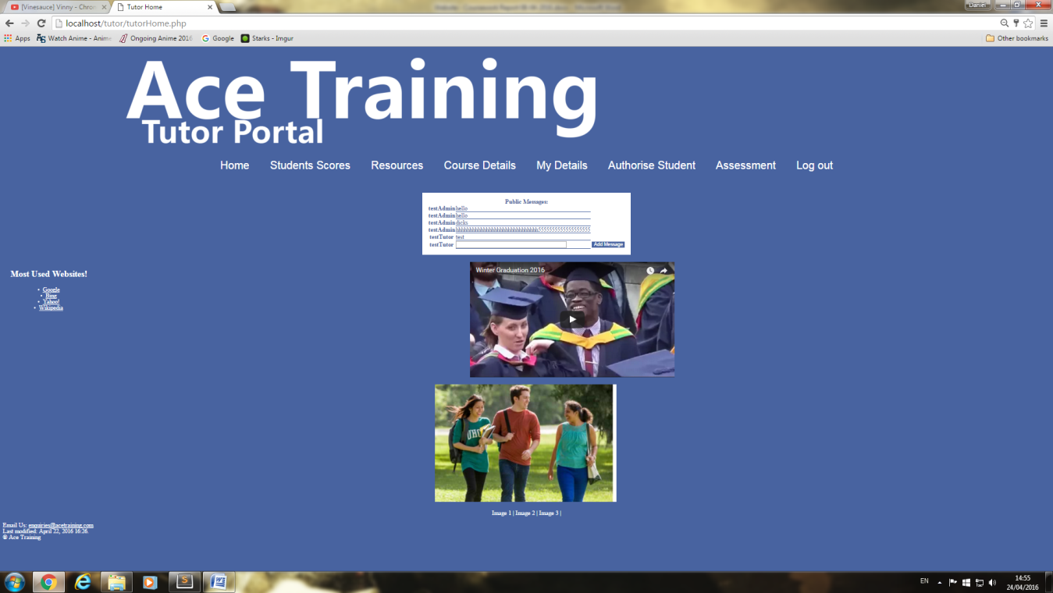

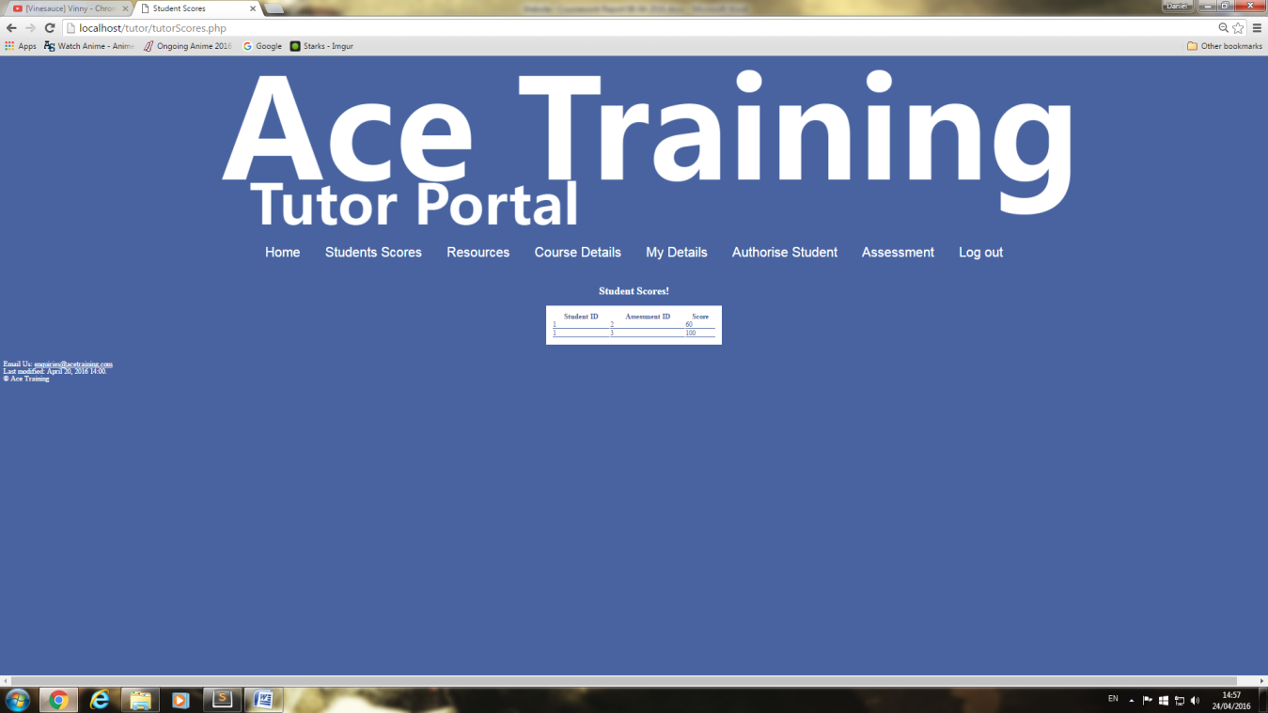This is the home page for the tutor I created the page itself plus all of the buttons that are displayed on the page.

This is the student Score page this allows the tutor to see students scores that are on their course.

# 

This is the resource page the tutor can see all the resource that are on their course also from here they can add and delete a resource that has been upload.

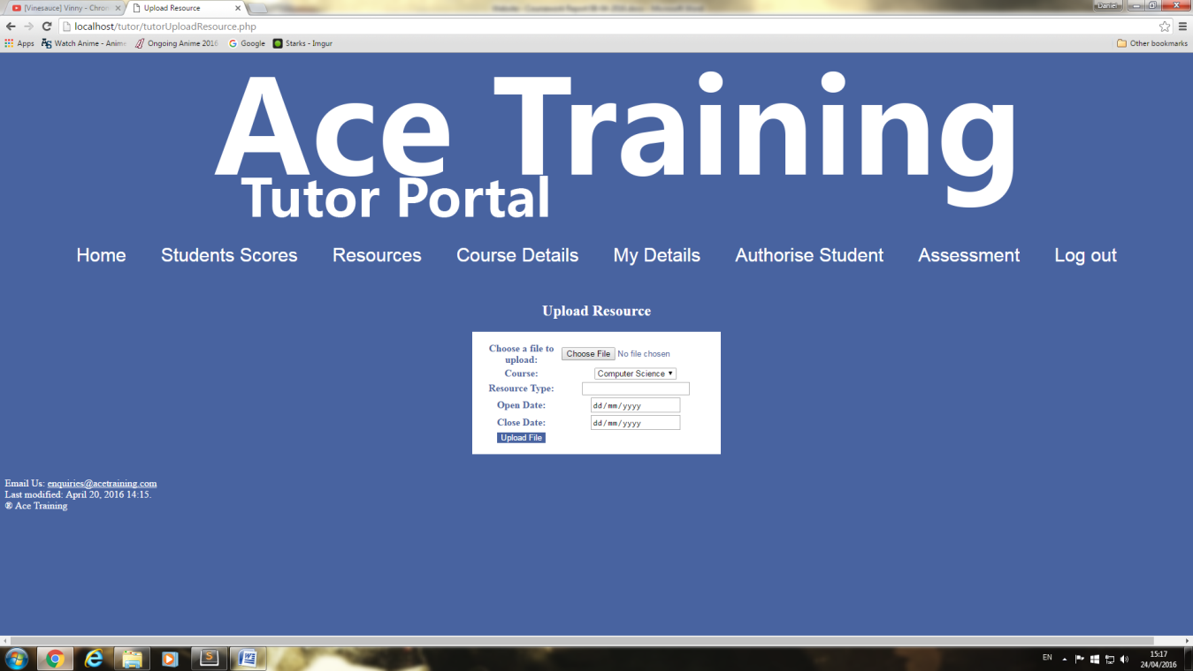

This is the add/upload resource page when the tutor wants to add a resource to the database they will enter in the details in the table when they are happy with these details they will click submit. Some validation has been applied to this page which I have created.

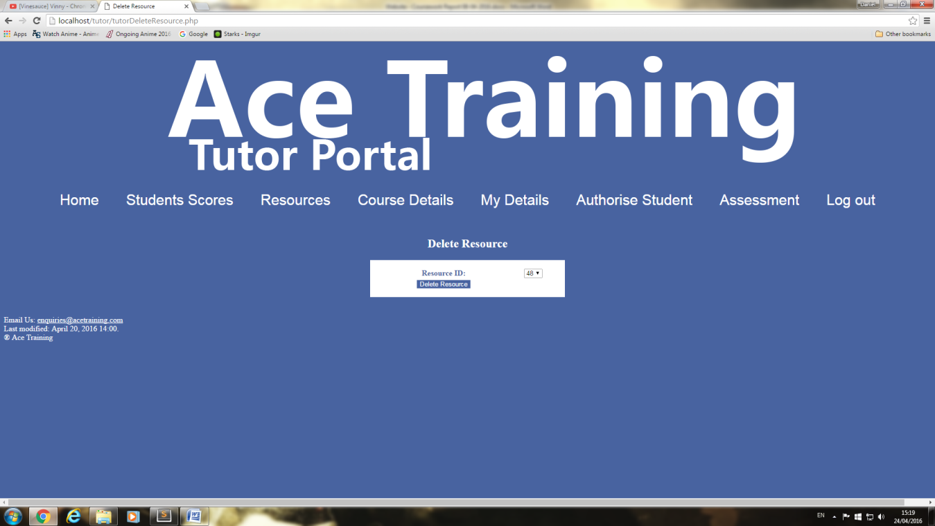

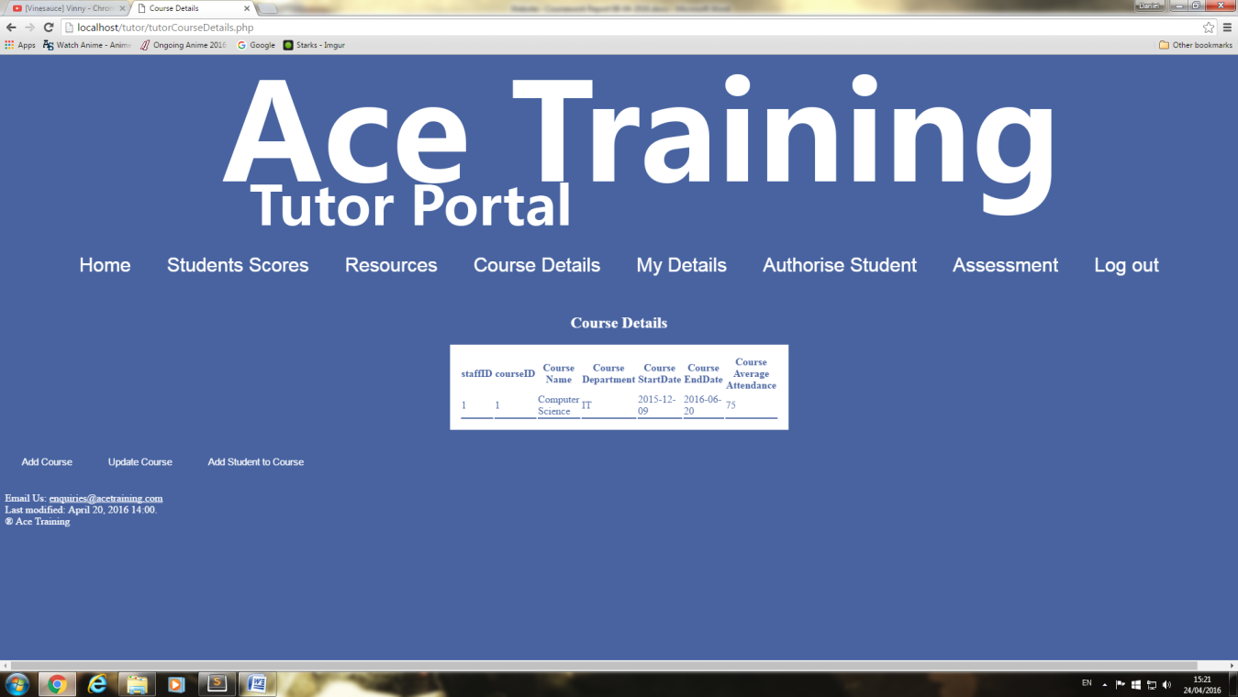This is the delete resource page when the tutor wants to delete a resource they will go onto this screen and find the id of that resource then click delete resource this will remove it from the database.

This is the course details pages when the tutor clicks on the course details page they will see this table that will display course information this will only show what courses that tutor has been applied to.

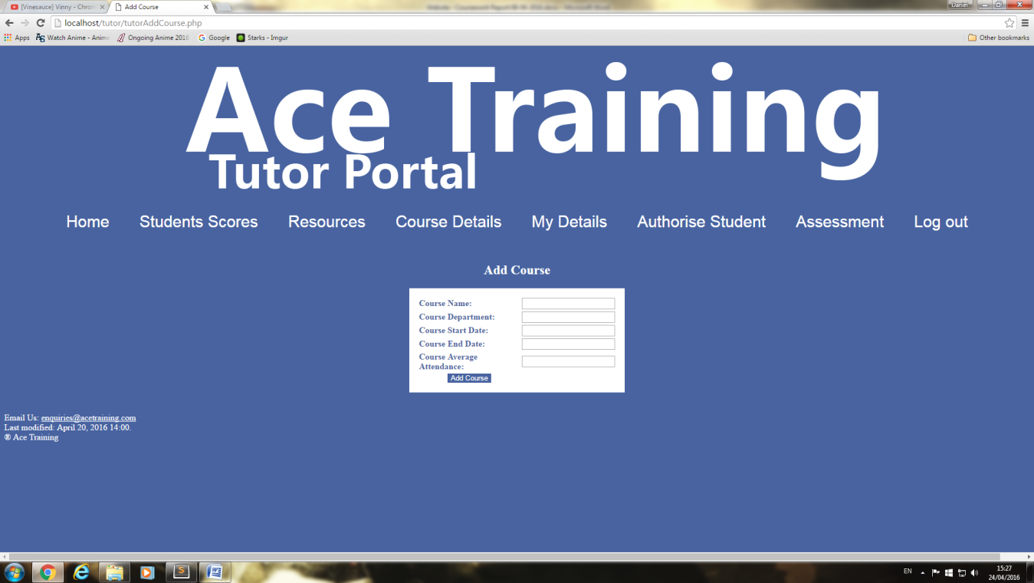

This is the add a course page when the tutors wants to add a course to the database they will need to go through this page. Validation has been add to this page which I have created.

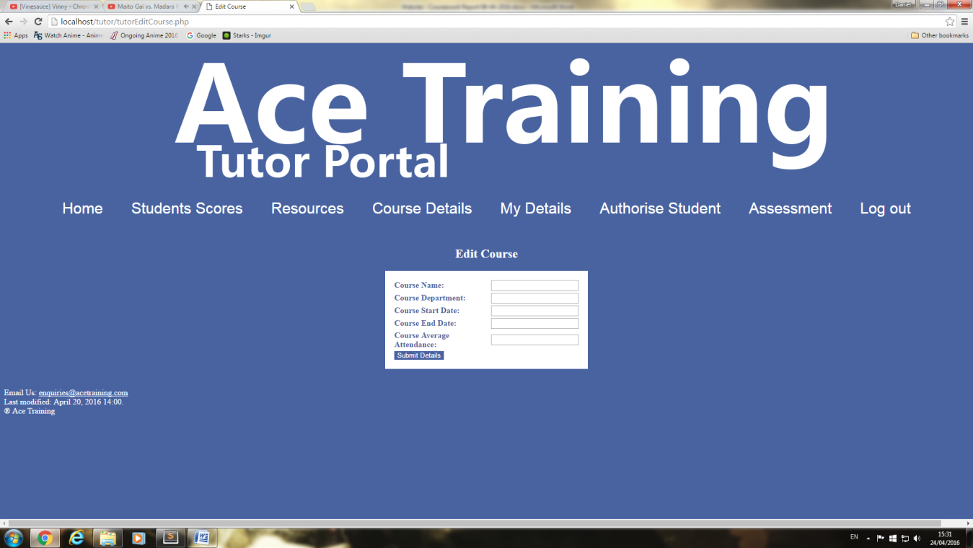

This is the edit course page this is where the tutor can edit a course that has been uploaded to the database already. Validation has been add to this page which I have created.

# 

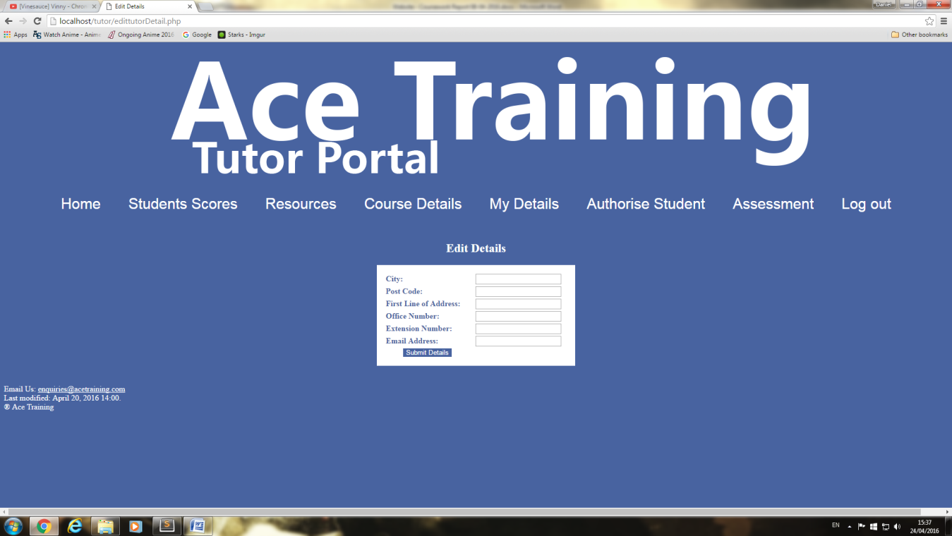This is the my details page for the tutor from here the tutor can see their own details which is displayed in the table in the center of the screen .

This is the edit details pages when the tutor wants to edit their own details they will come to this screen when they change their details on this page it will update the table on the my details page. Validation has been added to this page which I have created.

# 

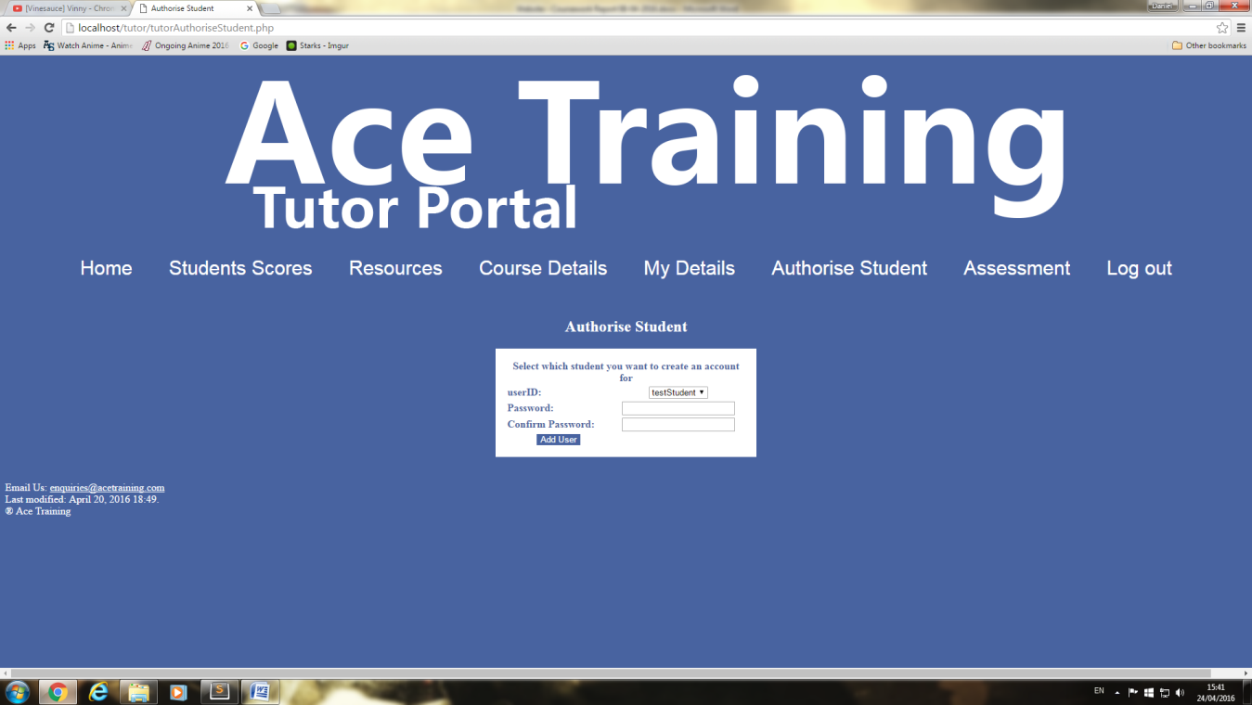  
This is the add assessment page from here the tutor can add assessments that the students can view and answer. Validation has been added to this page that I created.

This is the authorize student page when the tutor wants to authorize a user as a student they will go to this page to add a user both passwords need to be the same. Validation has been added to this page that I have created

# 

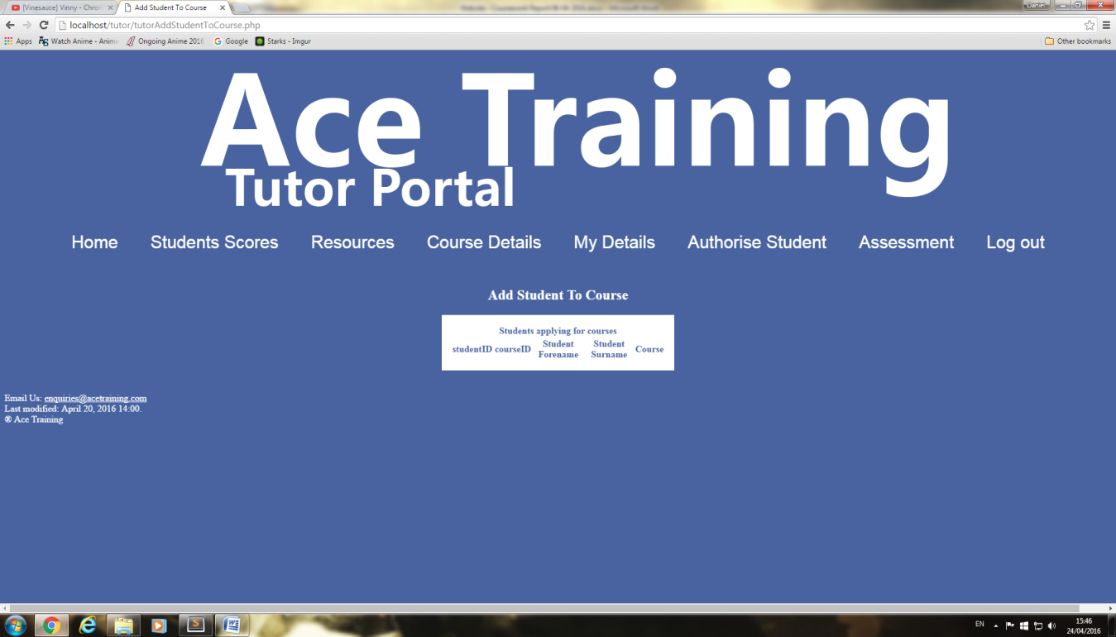  
  
  
This is the assessment page the tutor can see what assessments are on their course this will be shown to everyone on that course so even student can see these assessments.

This is the add student to course page when a student has been entered in a new course this table will show a record.

# Appendix

## Technical Documentation

**User Requirements**

In this section of the report we will outline the user requirements this will allows us to know what each user should be able to do on the site this is a very important section as it allows us to design our site around the user's needs.

**Student requirements**

While on the site the student will not be able to do a lot of functions as they are only a student they will not have many permissions that will affect the site taking this into account most of the requirements that the student will have is the ability to see information that will be displayed on the screen. Some pages will have extra feature which will allow the user to do more actions on that page for example when the student is on their details pages they will be able to see their own information and they will have the option to edit their details this is one of the few pages that allows the student to do another action.

So the requirements of the student is the ability to access their own home page with related pages which will display links that they can interact with on certain pages they can do more than one action but these actions will only affect that user so it won't affect the whole site.

**Tutor requirements**

while on the site the tutor will be able to do a lot of different functions these include adding information to the site, removing information and editing information all these functions will have certain limits as this user is the tutor they will not be able to do everything on the site as that would give them powers that they don't need. When the tutor logs on to their page they will be able to interact with all the links that are displayed most pages will have at least more than one extra function depending on the page will depend on the function for example in the resource page the tutor will be able to do three function this includes adding, removing and editing other pages like my details will only have one function which lets them edit their own information this is the prevent damage to the site.

So the requirements of the tutor is the ability to access their own home page with related pages which will display links that they can interact with on most pages they can do more than one action which does include add, remove and edit these will be limited to small changes in the site as it would be dangerous to give a lot of big changing permissions.

**Admin requirements**

While on the site the admin will be able to do most functions on the site as they are in charge of maintains and admin duties they will need access to everything this user is kind of like an tutor but with more permissions in certain areas for example admin can remove both tutors and students these are admin only permissions as it would be pointless and dangerous to give them to the other users. Not only do admin have permission on most areas they have access to most records that are stored on the database for example tutor can only see students that are only on their course this is the same for other tutors while an admin can see every student and can see every tutor this is another admin only permission.

So the requirements of the admin is the ability to access their own home page with related pages which will display links that they can interact with and they can see all users that are entered in database not only that but they have the ability to do most functions on the database this means they have little to no limit when it comes to adding, removing and editing out of all the users this user has the most interaction with the database and the site itself.

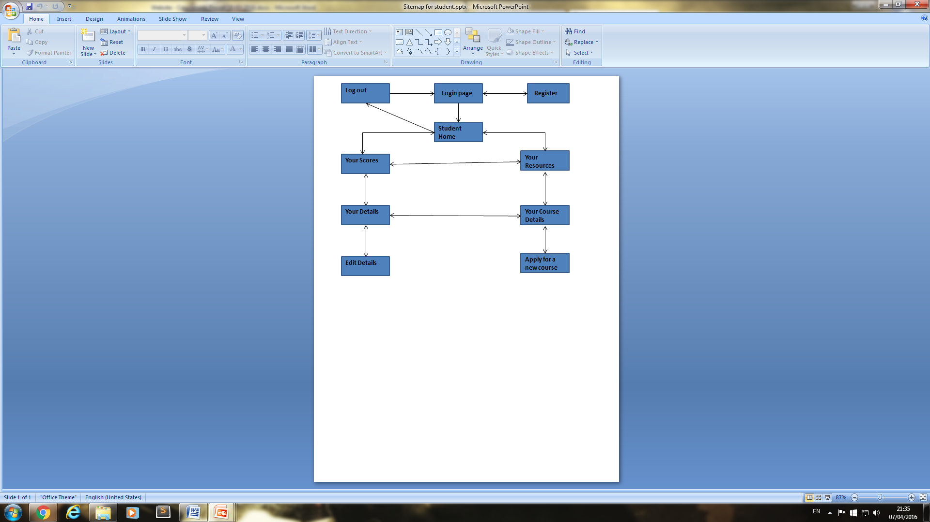**Site Map**

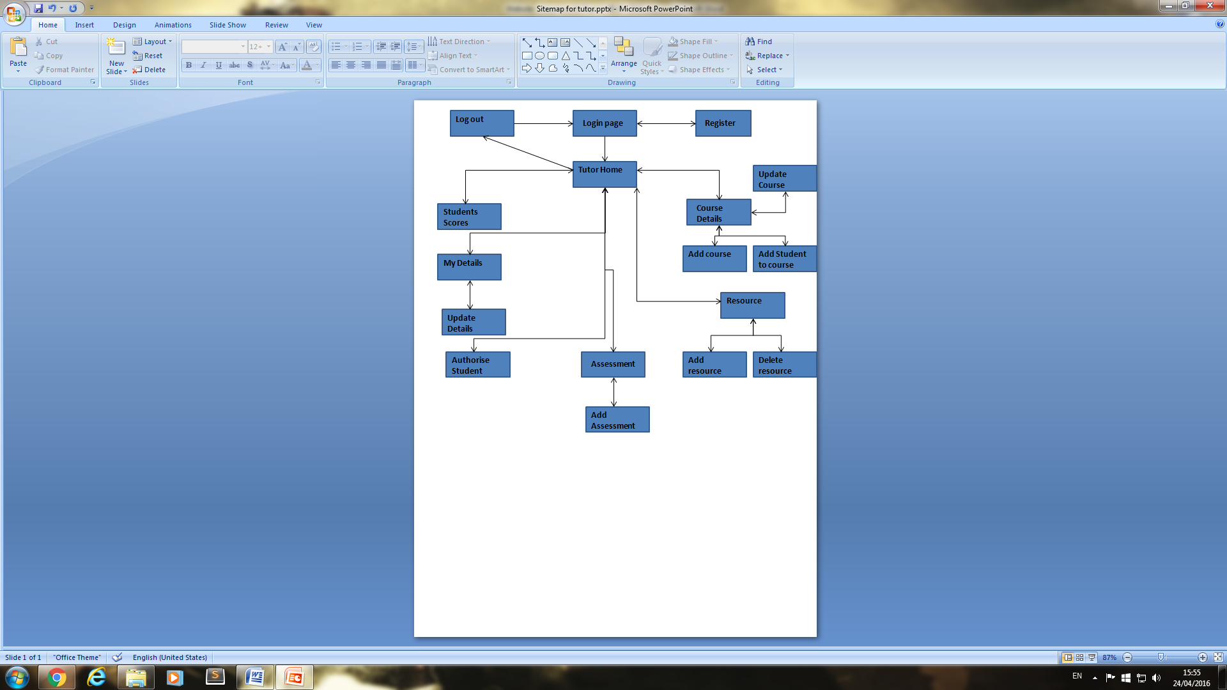

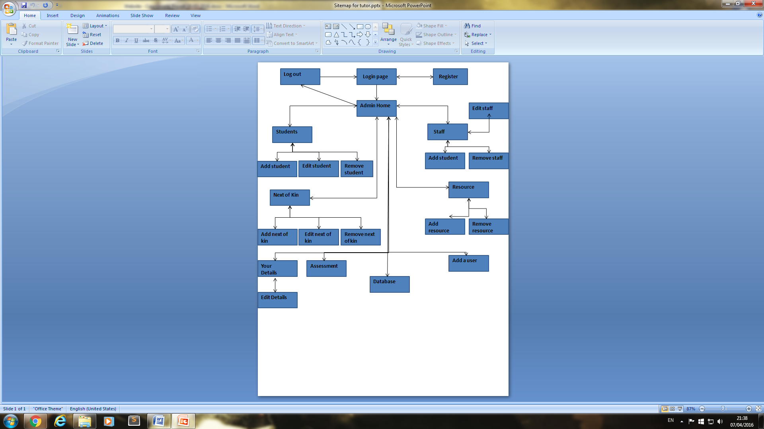

**Storyboards**

Ace Training-Login page

Login:

Password:

Login

Don't have a student account? Register

Enter your username and password below

This is the login page for the website, a fairly simple page which allows the user to enter their username and password so that they can login to their account. The text at the bottom is a link to the register page .

Forename:

Register

Surname:

DOB:

City:

Postcode:

First Line of Address:

Second Line of Address:

Email Address:

Account Name:

This is the register page this page allows the user to enter in their details so that an account can be created. Once an account is created, they will have authorization to log on to the website. There is one button on this page which when clicked will take you to back to the login page.

Ace Training-Register

Ace Training-Student home

Home

Your Scores

Your Resources

Your course details

Your Details

Last modified: date will be displayed here

Log out

This is the home page, this page will contain the main website information below the title will be links to all available pages on the website that relate to that user.

This is the home page, this page will contain the main website information below the title will be links to all available pages on the website that relate to that user.

Ace Training-Tutor home

Home

Student Scores

Resources

Course details

My Details

Log out

Last modified: date will be displayed here

Authorise student

Ace Training-Admin home

Home

Student

Staff

Next of \Kin

Your Details

Log out

Last modified: date will be displayed here

Resource

Database

Add a user

Assessment

This is the home page, this page will contain the main website information below the title will be links to all available pages on the website that relate to that user.

Ace Training-Student scores

Home

Your Scores

Your Resources

Your course details

Your Details

Table of information about student

Log out

Last modified: date will be displayed here

This is the student scores page it will display that students scores in the table which will be in the middle of the screen.

This is the student resources page it will display resources that relate to that student also they can download the resource.

Ace Training-Student resources

Home

Your Scores

Your Resources

Your course details

Your Details

Table of information about resources

Log out

Last modified: date will be displayed here

Ace Training-Student course details

Home

Your Scores

Your Resources

Your course details

Your Details

Table of information about course details

Log out

Last modified: date will be displayed here

Apply for a new course

This is the student course details page it will display the courses which that student is taking.

This is the student apply for new course page it will allow the student to apply for a new course. In the middle will be a table that the user will fill out this will tell the database what course they are applying for and sign them to that course.

Ace Training-Student new course

Home

Your Scores

Your Resources

Your course details

Your Details

User interaction section here

Log out

Last modified: date will be displayed here

Ace Training-Student your details

Home

Your Scores

Your Resources

Your course details

Your Details

Will display information about the student

Log out

Last modified: date will be displayed here

Edit details

This is the student your details page it will display that students personal details in the table which will be in the middle of the screen.

Ace Training-Student edit details

Home

Your Scores

Your Resources

Your course details

Your Details

User interaction will be here

Log out

Last modified: date will be displayed here

This is the student edit details page it will allow the student to make changes to their personal information. In the middle will be a table that the user will fill out this will tell the database to change its information about the user.

Ace Training-Tutor Student scores

Home

Student Scores

Resources

Course details

My Details

Log out

Last modified: date will be displayed here

Will display information about the students in that tutors course

Authorise student

Assessment

This is the tutor student scores page it will display the students' scores that are in that tutors course.

Ace Training-Tutor resources

Home

Student Scores

Resources

Course details

My Details

Log out

Last modified: date will be displayed here

Table of information about resources

Add resource

Delete resource

Authorise student

Assessment

This is the tutor resources page it will display resources that the tutor has uploaded .

Ace Training-Tutor add resource

Home

Student Scores

Resources

Course details

My Details

Log out

Last modified: date will be displayed here

User interaction will be here

Authorise student

Assessment

This is the tutor add resource page it will allow the tutor to add resources to the database and site. In the middle will be a table that the user will fill out this will tell the database to add the resource.

Ace Training-Tutor delete resource

Home

Student Scores

Resources

Course details

My Details

Log out

Last modified: date will be displayed here

User interaction will be here

Authorise student

Assessment

This is the delete resource page the tutor can delete resource that have been uploaded to the site from here.

Ace Training-Tutor course details

Home

Student Scores

Resources

Course details

My Details

Log out

Last modified: date will be displayed here

Table of information about course details

Add course

Update course

Add student to course

Authorise student

Assessment

This is the tutor course details page it will display the courses which that tutor is taking.

Ace Training-Tutor add course

Home

Student Scores

Resources

Course details

My Details

Log out

Last modified: date will be displayed here

User interaction will be here

Authorise student

Assessment

This is the tutor add course page it will allow the tutor to add course to the database and site. In the middle will be a table that the user will fill out this will tell the database to add the course.

This is the tutor update course page it will allow the tutor to make changes to a course. In the middle will be a table that the user will fill out this will tell the database to change its information about the course.

Ace Training-Tutor update course

Home

Student Scores

Resources

Course details

My Details

Log out

Last modified: date will be displayed here

User interaction will be here

Authorise student

Assessment

Ace Training-Tutor add student to course

Home

Student Scores

Resources

Course details

My Details

Log out

Last modified: date will be displayed here

User interaction will be here

Authorise student

Assessment

This is the tutor add student and course page it will allow the tutor to add a student onto a course. In the middle will be a table that the user will fill out this will tell the database to add the student to a course.

Ace Training-Tutor my details

Home

Student Scores

Resources

Course details

My Details

Log out

Last modified: date will be displayed here

Table of information about course details

Update Details

Authorise student

Assessment

This is the tutor my details page it will display the tutors personal information.

This is the tutor update details page it will allow the tutor to make changes to their personal details. In the middle will be a table that the user will fill out this will tell the database to change its information about the user.

Ace Training-Tutor update details

Home

Student Scores

Resources

Course details

My Details

Log out

Last modified: date will be displayed here

Authorise student

User interaction will be here

Assessment

Ace Training-Tutor Authorise student

Home

Student Scores

Resources

Course details

My Details

Log out

Last modified: date will be displayed here

Authorise student

User interaction will be here

Assessment

This is the tutor authorise student page it will allow the tutor to authorise a student. In the middle will be a table that the user will fill out this will tell the database to authorise this user as a student.

Ace Training-Tutor Assessment

Home

Student Scores

Resources

Course details

My Details

Log out

Last modified: date will be displayed here

Table of information about assessment

Add Assessment

Authorise student

Assessment

This is the tutor assessment page it will display assessment.

Ace Training-Tutor Add assessment

Home

Student Scores

Resources

Course details

My Details

Log out

Last modified: date will be displayed here

Authorise student

User interaction will be here

Assessment

This is the tutor add assessment page it will allow the tutor to add assessment. In the middle will be a table that the user will fill out this will tell the database to add this assessment to the database.

Ace Training-Admin student details

Home

Student

Staff

Next of \Kin

Your Details

Log out

Last modified: date will be displayed here

Resource

Database

Add a user

Assessment

Table of information about students

Add a student

Edit student details

Delete student details

This is the admin student details page it will display students that are on the database.

Ace Training-Admin add a student

Home

Student

Staff

Next of \Kin

Your Details

Log out

Last modified: date will be displayed here

Resource

Database

Add a user

Assessment

User interaction will be here

This is the admin add a student page it will allow the admin to add a student. In the middle will be a table that the user will fill out this will tell the database to add a student.

Ace Training-Admin edit student details

Home

Student

Staff

Next of \Kin

Your Details

Log out

Last modified: date will be displayed here

Resource

Database

Add a user

Assessment

User interaction will be here

This is the admin edit a student page it will allow the admin to edit a student. In the middle will be a table that the user will fill out this will tell the database to edit a student.

Ace Training-Admin delete student details

Home

Student

Staff

Next of \Kin

Your Details

Log out

Last modified: date will be displayed here

Resource

Database

Add a user

Assessment

User interaction will be here

This is the admin delete a student page it will allow the admin to delete a student. In the middle will be a table that the user will fill out this will tell the database to delete a student.

Ace Training-Admin staff

Home

Student

Staff

Next of \Kin

Your Details

Log out

Last modified: date will be displayed here

Resource

Database

Add a user

Assessment

Table of information about staff

Add staff member

Edit staff member

Delete staff member

This is the admin staff page it will display staff that are on the database.

Ace Training-Admin add staff member

Home

Student

Staff

Next of \Kin

Your Details

Log out

Last modified: date will be displayed here

Resource

Database

Add a user

Assessment

User interaction will be here

This is the admin add a student page it will allow the admin to add a student. In the middle will be a table that the user will fill out this will tell the database to add a student.

Ace Training-Admin edit staff member

Home

Student

Staff

Next of \Kin

Your Details

Log out

Last modified: date will be displayed here

Resource

Database

Add a user

Assessment

User interaction will be here

This is the admin add a student page it will allow the admin to add a student. In the middle will be a table that the user will fill out this will tell the database to add a student.

Ace Training-Admin delete staff member

Home

Student

Staff

Next of \Kin

Your Details

Log out

Last modified: date will be displayed here

Resource

Database

Add a user

Assessment

User interaction will be here

This is the admin add a student page it will allow the admin to add a student. In the middle will be a table that the user will fill out this will tell the database to add a student.

Ace Training-Admin next of kin

Home

Student

Staff

Next of \Kin

Your Details

Log out

Last modified: date will be displayed here

Resource

Database

Add a user

Assessment

Table of information about next of kin

Add next of kin

Edit next of kin

Delete next of kin

This is the admin next of kin page it will display next of kin that are on the database.

Ace Training-Admin add next of kin

Home

Student

Staff

Next of \Kin

Your Details

Log out

Last modified: date will be displayed here

Resource

Database

Add a user

Assessment

User interaction will be here

This is the admin add next of kin page it will allow the admin to add a next of kin. In the middle will be a table that the user will fill out this will tell the database to add a next of kin.

Ace Training-Admin edit next of kin

Home

Student

Staff

Next of \Kin

Your Details

Log out

Last modified: date will be displayed here

Resource

Database

Add a user

Assessment

User interaction will be here

This is the admin edit next of kin page it will allow the admin to edit next of kin. In the middle will be a table that the user will fill out this will tell the database to edit next of kin.

Ace Training-Admin delete next of kin

Home

Student

Staff

Next of \Kin

Your Details

Log out

Last modified: date will be displayed here

Resource

Database

Add a user

Assessment

User interaction will be here

This is the admin delete next of kin page it will allow the admin to delete a next of kin. In the middle will be a table that the user will fill out this will tell the database to delete a next of kin.

Ace Training-Admin your details

Home

Student

Staff

Next of \Kin

Your Details

Log out

Last modified: date will be displayed here

Resource

Database

Add a user

Assessment

Table of information about admin details

Edit details

This is the admin your details page it will display the admin details that are on the database.

Ace Training-Admin edit your details

Home

Student

Staff

Next of \Kin

Your Details

Log out

Last modified: date will be displayed here

Resource

Database

Add a user

Assessment

User interaction will be here

This is the admin edit your details page it will allow the admin to edit their details. In the middle will be a table that the user will fill out this will tell the database to edit the admin details.

Ace Training-Admin resource

Home

Student

Staff

Next of \Kin

Your Details

Log out

Last modified: date will be displayed here

Resource

Database

Add a user

Assessment

Table of information about resource

Add resource

Delete resource

This is the admin resource page it will display resource that are on the database.

Ace Training-Admin add resource

Home

Student

Staff

Next of \Kin

Your Details

Log out

Last modified: date will be displayed here

Resource

Database

Add a user

Assessment

User interaction will be here

This is the admin add a resource page it will allow the admin to add a resource. In the middle will be a table that the user will fill out this will tell the database to add a resource.

Ace Training-Admin delete resource

Home

Student

Staff

Next of \Kin

Your Details

Log out

Last modified: date will be displayed here

Resource

Database

Add a user

Assessment

User interaction will be here

This is the admin delete a resource page it will allow the admin to delete a resource. In the middle will be a table that the user will fill out this will tell the database to delete a resource.

Ace Training-Admin assessment

Home

Student

Staff

Next of \Kin

Your Details

Log out

Last modified: date will be displayed here

Resource

Database

Add a user

Assessment

Table of information about assessment

This is the admin assessment page it will display assessments that are on the database.

Ace Training-Admin database

Home

Student

Staff

Next of \Kin

Your Details

Log out

Last modified: date will be displayed here

Resource

Database

Add a user

Assessment

User interaction will be here

This is the admin database page it will display the commands that the admin can use on the database.

Ace Training-Admin add a user

Home

Student

Staff

Next of \Kin

Your Details

Log out

Last modified: date will be displayed here

Resource

Database

Add a user

Assessment

User interaction will be here

This is the admin add a user page it will allow the admin to add a user.

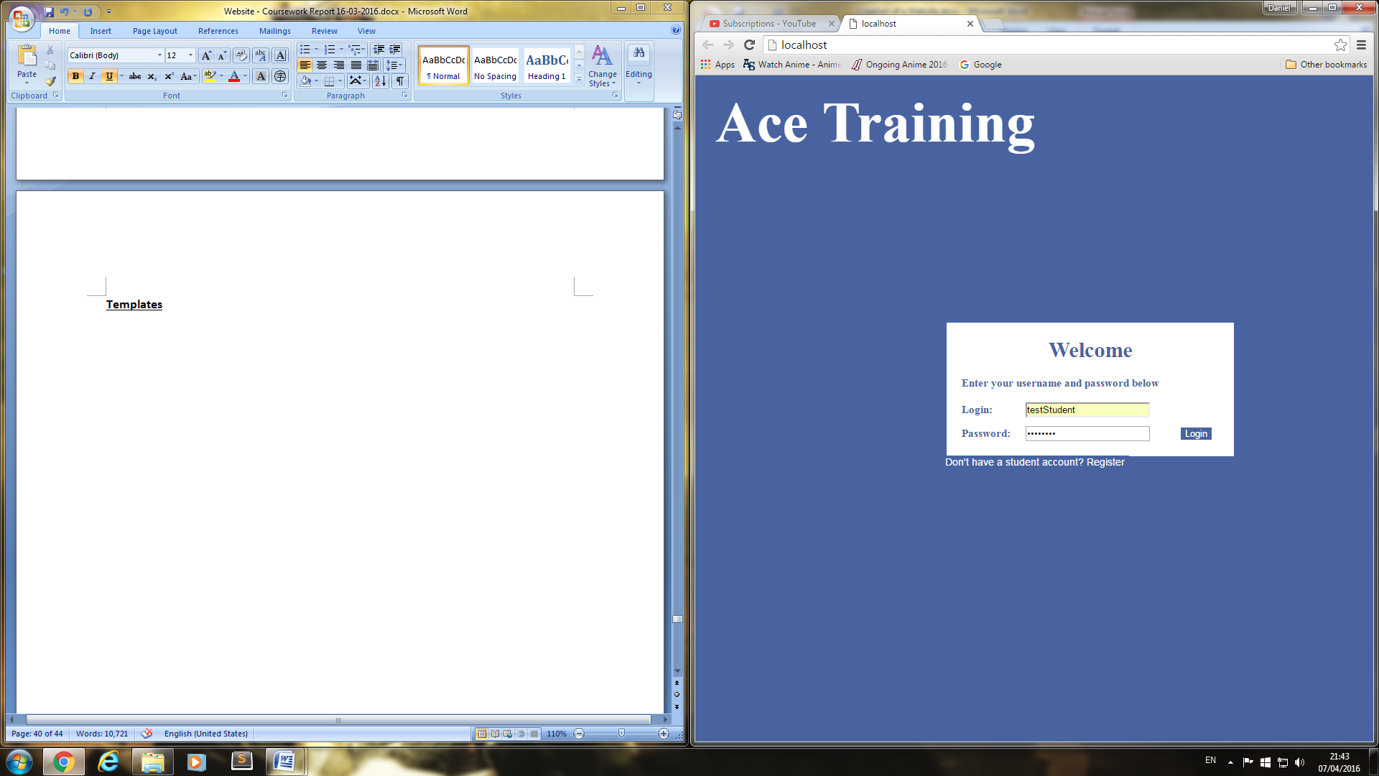**Templates**

**Login page**

Login Form, containing username and password also will have a link at the bottom of the table.

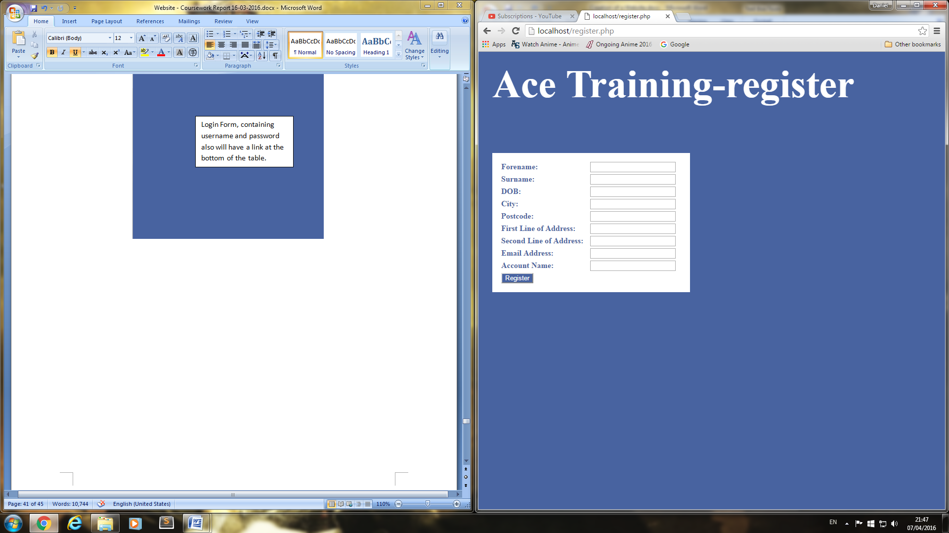**Register page**

Register form containing suitable attributes for the user to fill out for creating an account.

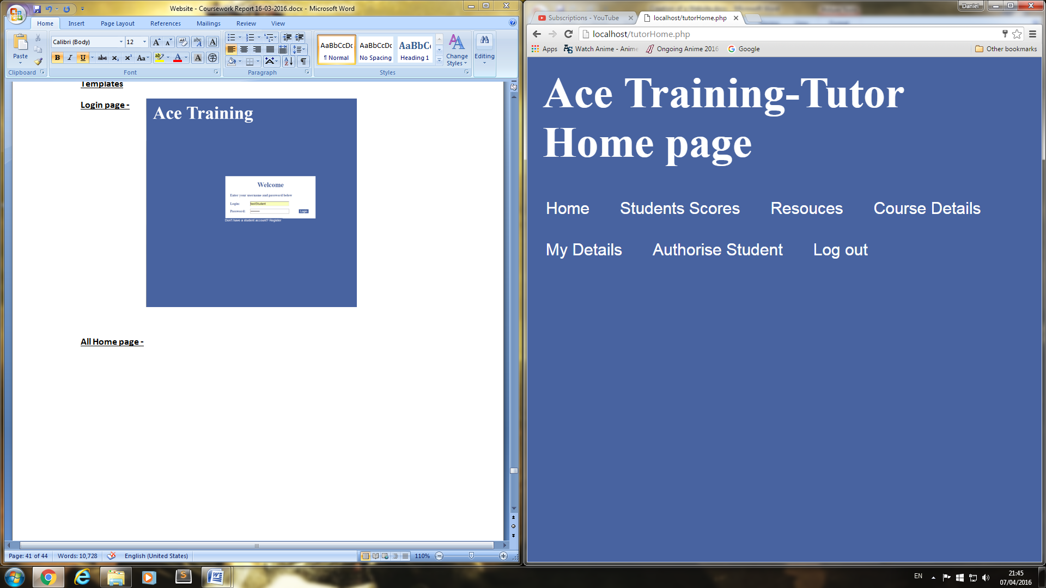**All Home page**

Buttons for navigation around website

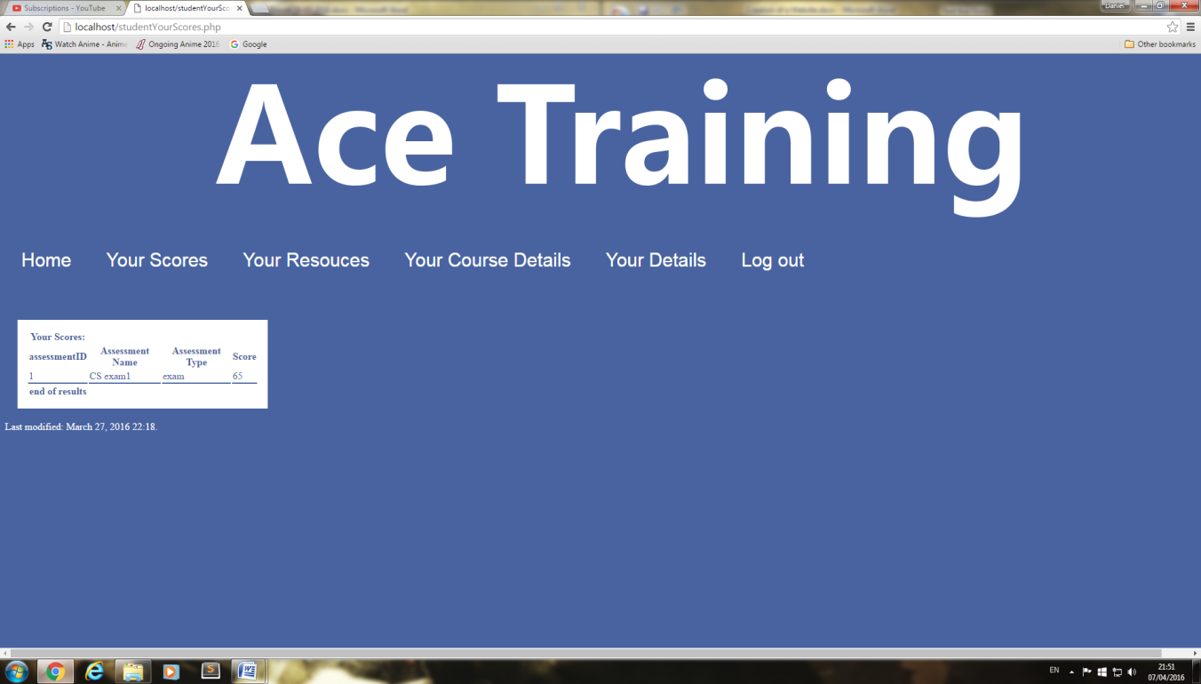**All scores page**

Buttons for navigation around website

Table that will display information

**All resources page  
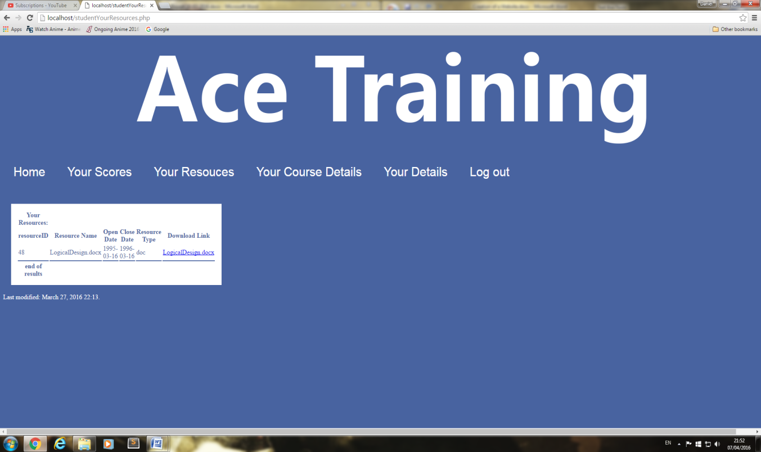**

Table that will display information

Buttons for navigation around website

**All course details page**

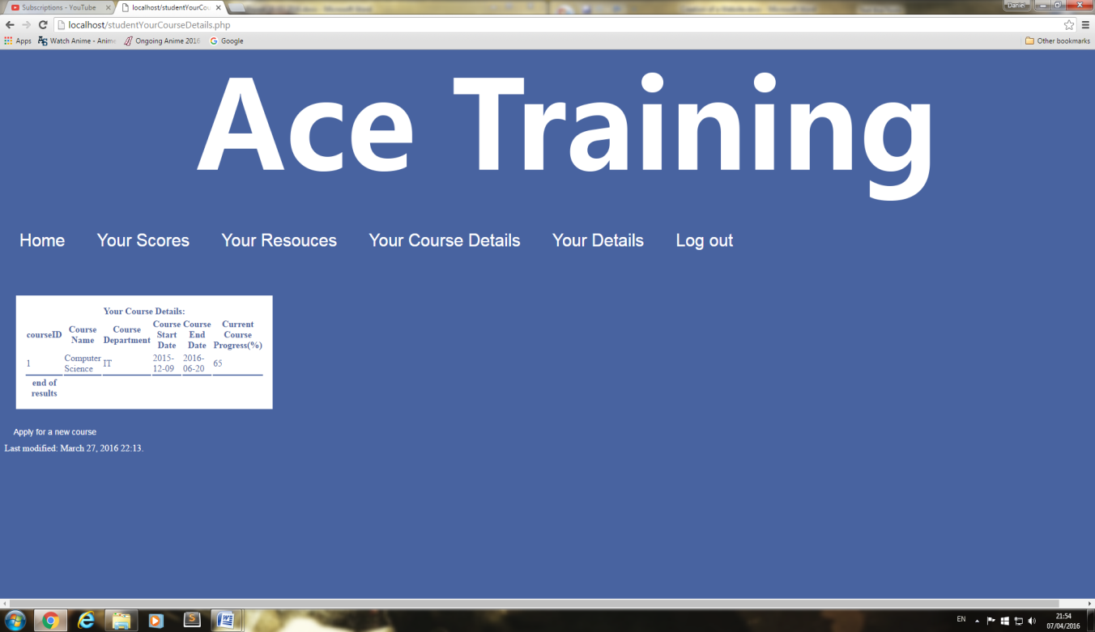

Table that will display information

Buttons for navigation around website

**All your details page**

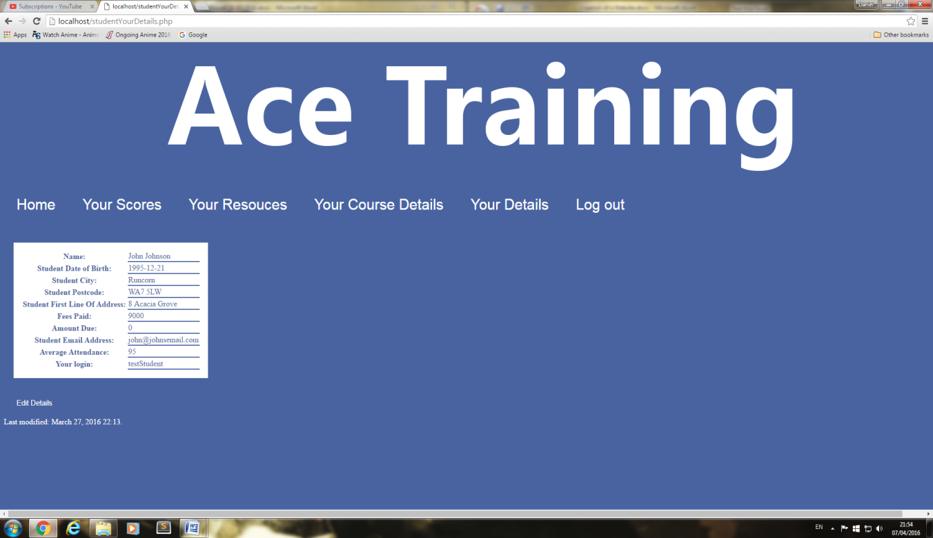

Table that will display information

Buttons for navigation around website

**All Edit your details page**



Buttons for navigation around website

Table that will display information

**All add resource page  
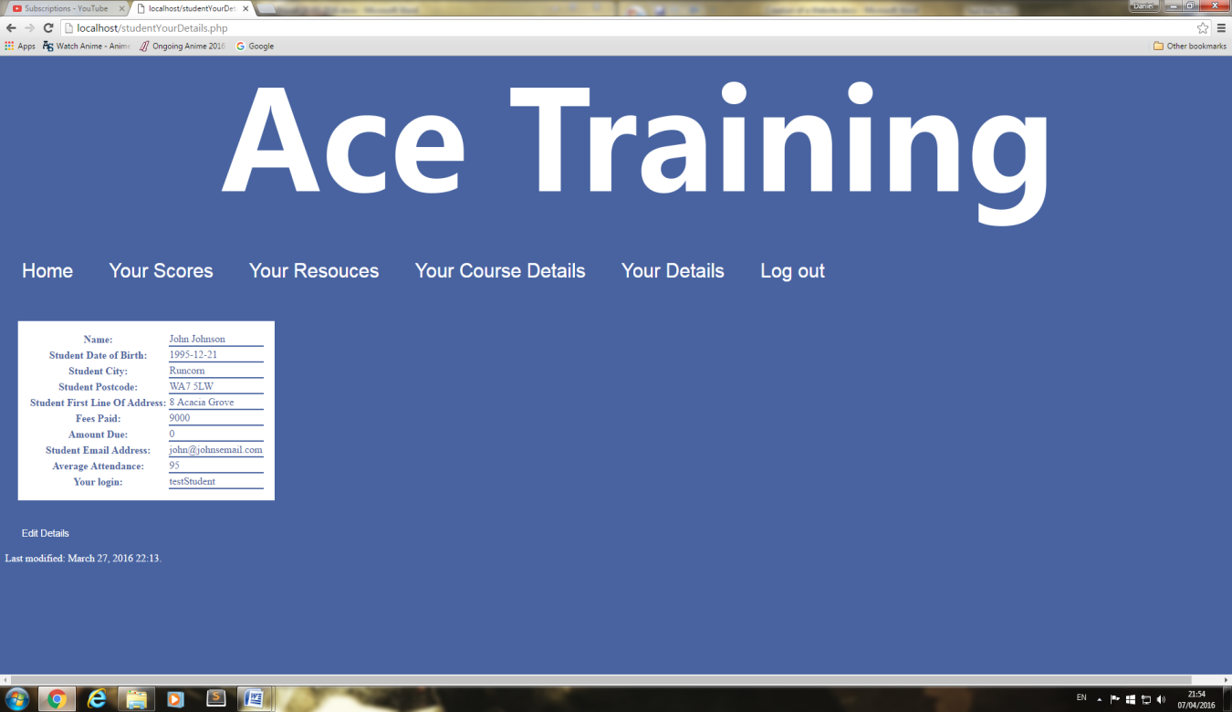**

Buttons for navigation around website

Table that will display information

**All delete resource pages**



Buttons for navigation around website

Table that will display information

**All Authorize student  
**

Table that will display information

Buttons for navigation around website

**All student page**



Table that will display information

Buttons for navigation around website

**All Staff page**



Table that will display information

Buttons for navigation around website

**All Next of kin pages**



Buttons for navigation around website

Table that will display information

**All add students page**



Buttons for navigation around website

Table that will display information

**All edit student page**



Buttons for navigation around website

Table that will display information

**All delete student page**



Buttons for navigation around website

Table that will display information

**All add staff member page**



Buttons for navigation around website

Table that will display information

**All edit staff member page**



Buttons for navigation around website

Table that will display information

**All delete staff member page**



Buttons for navigation around website

Table that will display information

**All add a next of kin page**



Buttons for navigation around website

Table that will display information

**All edit a next of details page**



Buttons for navigation around website

Table that will display information

**All delete next of kin details pages**



Buttons for navigation around website

Table that will display information

**All assessment pages**



Buttons for navigation around website

Table that will display information

**All database pages**



Buttons for navigation around website

Table that will display information

**All add a user pages**



Buttons for navigation around website

Table that will display information

**CSS printouts with comments**

* Background will be a steel blue colour as it will mix well.
* Titles will be size 56 and will be bold.
* All text will be white and be size 10 also their font will be Microsoft YaHei UI.
* Buttons will be font size 20 and will have the same background colour as the main background with white text.

Ace Training-Login page

Login:

Password:

Login

Don't have a student account? Register

Enter your username and password below

* Background will be a steel blue colour as it will mix well with the text colour and the loge image.
* Titles will be size 56 and will be bold.
* All text will be white and be size 10 also their font will be Microsoft YaHei UI.
* Buttons will be font size 20 and will have the same background colour as the main background with white text.

Forename:

Register

Surname:

DOB:

City:

Postcode:

First Line of Address:

Second Line of Address:

Email Address:

Account Name:

Ace Training-Register page

* Background will be a steel blue colour as it will mix well.
* Titles will be size 56 and will be bold.
* All text will be white and be size 10 also their font will be Microsoft YaHei UI.
* Buttons will be font size 20 and will have the same background colour as the main background with white text.

Ace Training-All Home page

Home

Student

Staff

Next of \Kin

Your Details

Log out

Last modified: date will be displayed here

Resource

Database

Add a user

Assessment

Ace Training-All Students page

Home

Student

Staff

Next of \Kin

Your Details

Log out

Last modified: date will be displayed here

Resource

Database

Add a user

Assessment

* Background will be a steel blue colour as it will mix well.
* Titles will be size 56 and will be bold.
* All text will be white and be size 10 also their font will be Microsoft YaHei UI.
* Buttons will be font size 20 and will have the same background colour as the main background with white text.

Ace Training-All Students page

Home

Student

Staff

Next of \Kin

Your Details

Log out

Last modified: date will be displayed here

Resource

Database

Add a user

Assessment

* Background will be a steel blue colour as it will mix well.
* Titles will be size 56 and will be bold.
* All text will be white and be size 10 also their font will be Microsoft YaHei UI.
* Buttons will be font size 20 and will have the same background colour as the main background with white text.
* Background will be a steel blue colour as it will mix well.
* Titles will be size 56 and will be bold.
* All text will be white and be size 10 also their font will be Microsoft YaHei UI.
* Buttons will be font size 20 and will have the same background colour as the main background with white text.

Ace Training-All Next of kin page

Home

Student

Staff

Next of \Kin

Your Details

Log out

Last modified: date will be displayed here

Resource

Database

Add a user

Assessment

Ace Training-All Details page

Home

Student

Staff

Next of Kin

Your Details

Log out

Last modified: date will be displayed here

Resource

Database

Add a user

Assessment

* Background will be a steel blue colour as it will mix well.
* Titles will be size 56 and will be bold.
* All text will be white and be size 10 also their font will be Microsoft YaHei UI.
* Buttons will be font size 20 and will have the same background colour as the main background with white text.

Ace Training-All resource page

Home

Student

Staff

Next of \Kin

Your Details

Log out

Last modified: date will be displayed here

Resource

Database

Add a user

Assessment

* Background will be a steel blue colour as it will mix well.
* Titles will be size 56 and will be bold.
* All text will be white and be size 10 also their font will be Microsoft YaHei UI.
* Buttons will be font size 20 and will have the same background colour as the main background with white text.

Ace Training-All Assessment page page

Home

Student

Staff

Next of \Kin

Your Details

Log out

Last modified: date will be displayed here

Resource

Database

Add a user

Assessment

* Background will be a steel blue colour as it will mix well.
* Titles will be size 56 and will be bold.
* All text will be white and be size 10 also their font will be Microsoft YaHei UI.
* Buttons will be font size 20 and will have the same background colour as the main background with white text.

Ace Training-All databases page

Home

Student

Staff

Next of \Kin

Your Details

Log out

Last modified: date will be displayed here

Resource

Database

Add a user

Assessment

* Background will be a steel blue colour as it will mix well.
* Titles will be size 56 and will be bold.
* All text will be white and be size 10 also their font will be Microsoft YaHei UI.
* Buttons will be font size 20 and will have the same background colour as the main background with white text.

Ace Training-All add a user page

Home

Student

Staff

Next of \Kin

Your Details

Log out

Last modified: date will be displayed here

Resource

Database

Add a user

Assessment

* Background will be a steel blue colour as it will mix well.
* Titles will be size 56 and will be bold.
* All text will be white and be size 10 also their font will be Microsoft YaHei UI.
* Buttons will be font size 20 and will have the same background colour as the main background with white text.

Ace Training-All Students page

Home

Student

Staff

Next of \Kin

Your Details

Log out

Last modified: date will be displayed here

Resource

Database

Add a user

Assessment

* Background will be a steel blue colour as it will mix well.
* Titles will be size 56 and will be bold.
* All text will be white and be size 10 also their font will be Microsoft YaHei UI.
* Buttons will be font size 20 and will have the same background colour as the main background with white text.

Ace Training-All Authorise student page

Home

Student Scores

Resources

Course details

My Details

Log out

Last modified: date will be displayed here

Authorise student

* Background will be a steel blue colour as it will mix well.
* Titles will be size 56 and will be bold.
* All text will be white and be size 10 also their font will be Microsoft YaHei UI.
* Buttons will be font size 20 and will have the same background colour as the main background with white text.

# Reference list

WebWiseTeam. (10th October 2012). *What does the Data Protection Act (DPA) mean online?.* Available: http://www.bbc.co.uk/webwise/guides/data-protection-act. Last accessed 5th Mar 2016.

Government Digital Service. (23 September 2015). *Definition of disability under the Equality Act 2010.* Available: https://www.gov.uk/definition-of-disability-under-equality-act-2010. Last accessed 5th Mar 2016.

Government Digital Service. ( 22 September 2015). *Discrimination: your rights.* Available: https://www.gov.uk/discrimination-your-rights. Last accessed 5th Mar 2016.

Government Digital Service. (9 December 2014). *Privacy policy.*Available: https://www.gov.uk/help/privacy-policy. Last accessed 5th Mar 2016.

Dmitry Fadeyev. (February 18th, 2009). *9 Common Usability Mistakes In Web Design.* Available: https://www.smashingmagazine.com/2009/02/9-common-usability-blunders/. Last accessed 7th Mar 2016.

Peter Carey (1 Jun 2009). *Data Protection: A Practical Guide to U.K. and E.U. Law*. London: Oxford University Press, U.S.A.. p5-30.

Government Digital Service. (4 January 2016). *How copyright protects your work.* Available: https://www.gov.uk/copyright/overview. Last accessed 5th Mar 2016.